DATABASE SYSTEM PROJECT

Name: Karan 023-23-0208

Instructor: Dr Adil Khan

Title: Campus Event Management System

Description: This project is a **Java-based Event Participation Management System** with a **MySQL database backend**, designed to efficiently manage student registrations, event organization, and participation tracking. It allows:

* **Users** to register as either students or organizers.
* **Organizers** to create and manage events.
* **Students** to register for events and have their **attendance recorded**.
* **Feedback collection** from attendees after events.

1. ERD:

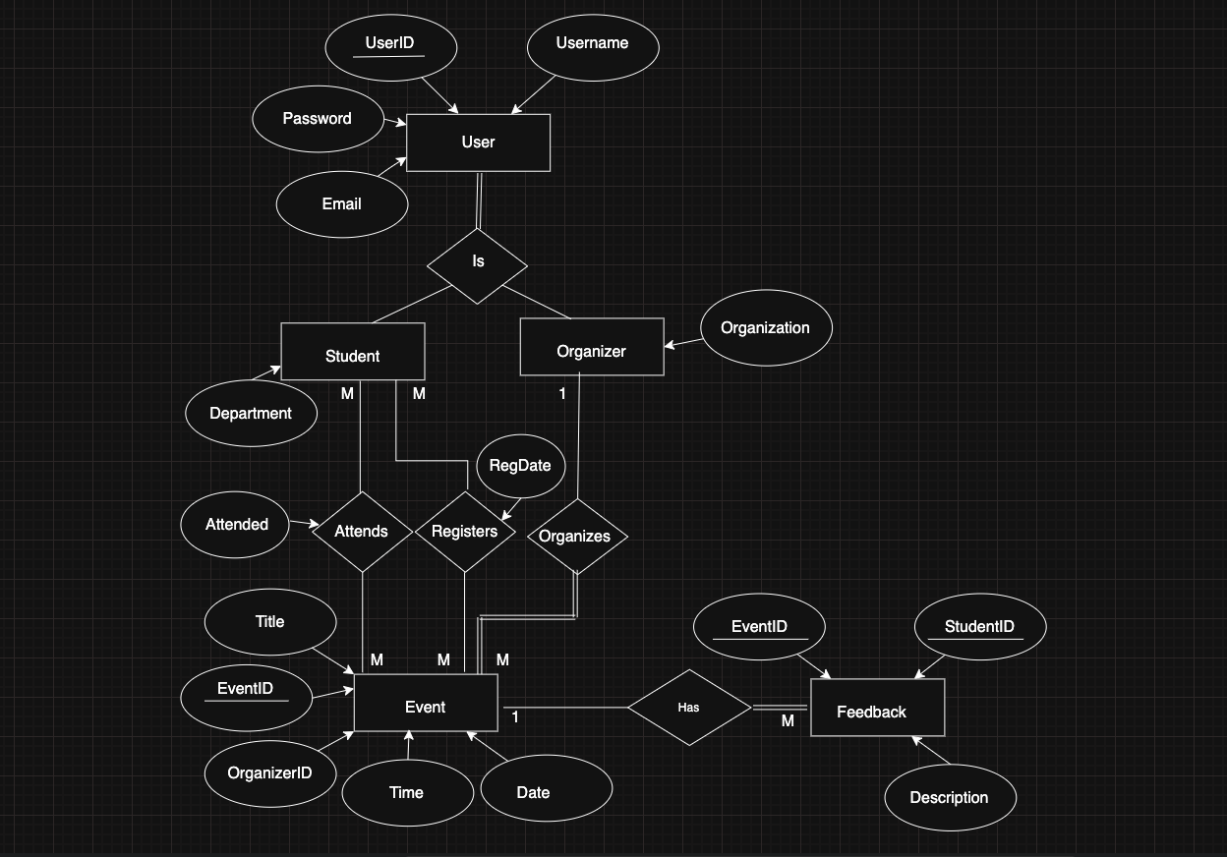

1. Normalization

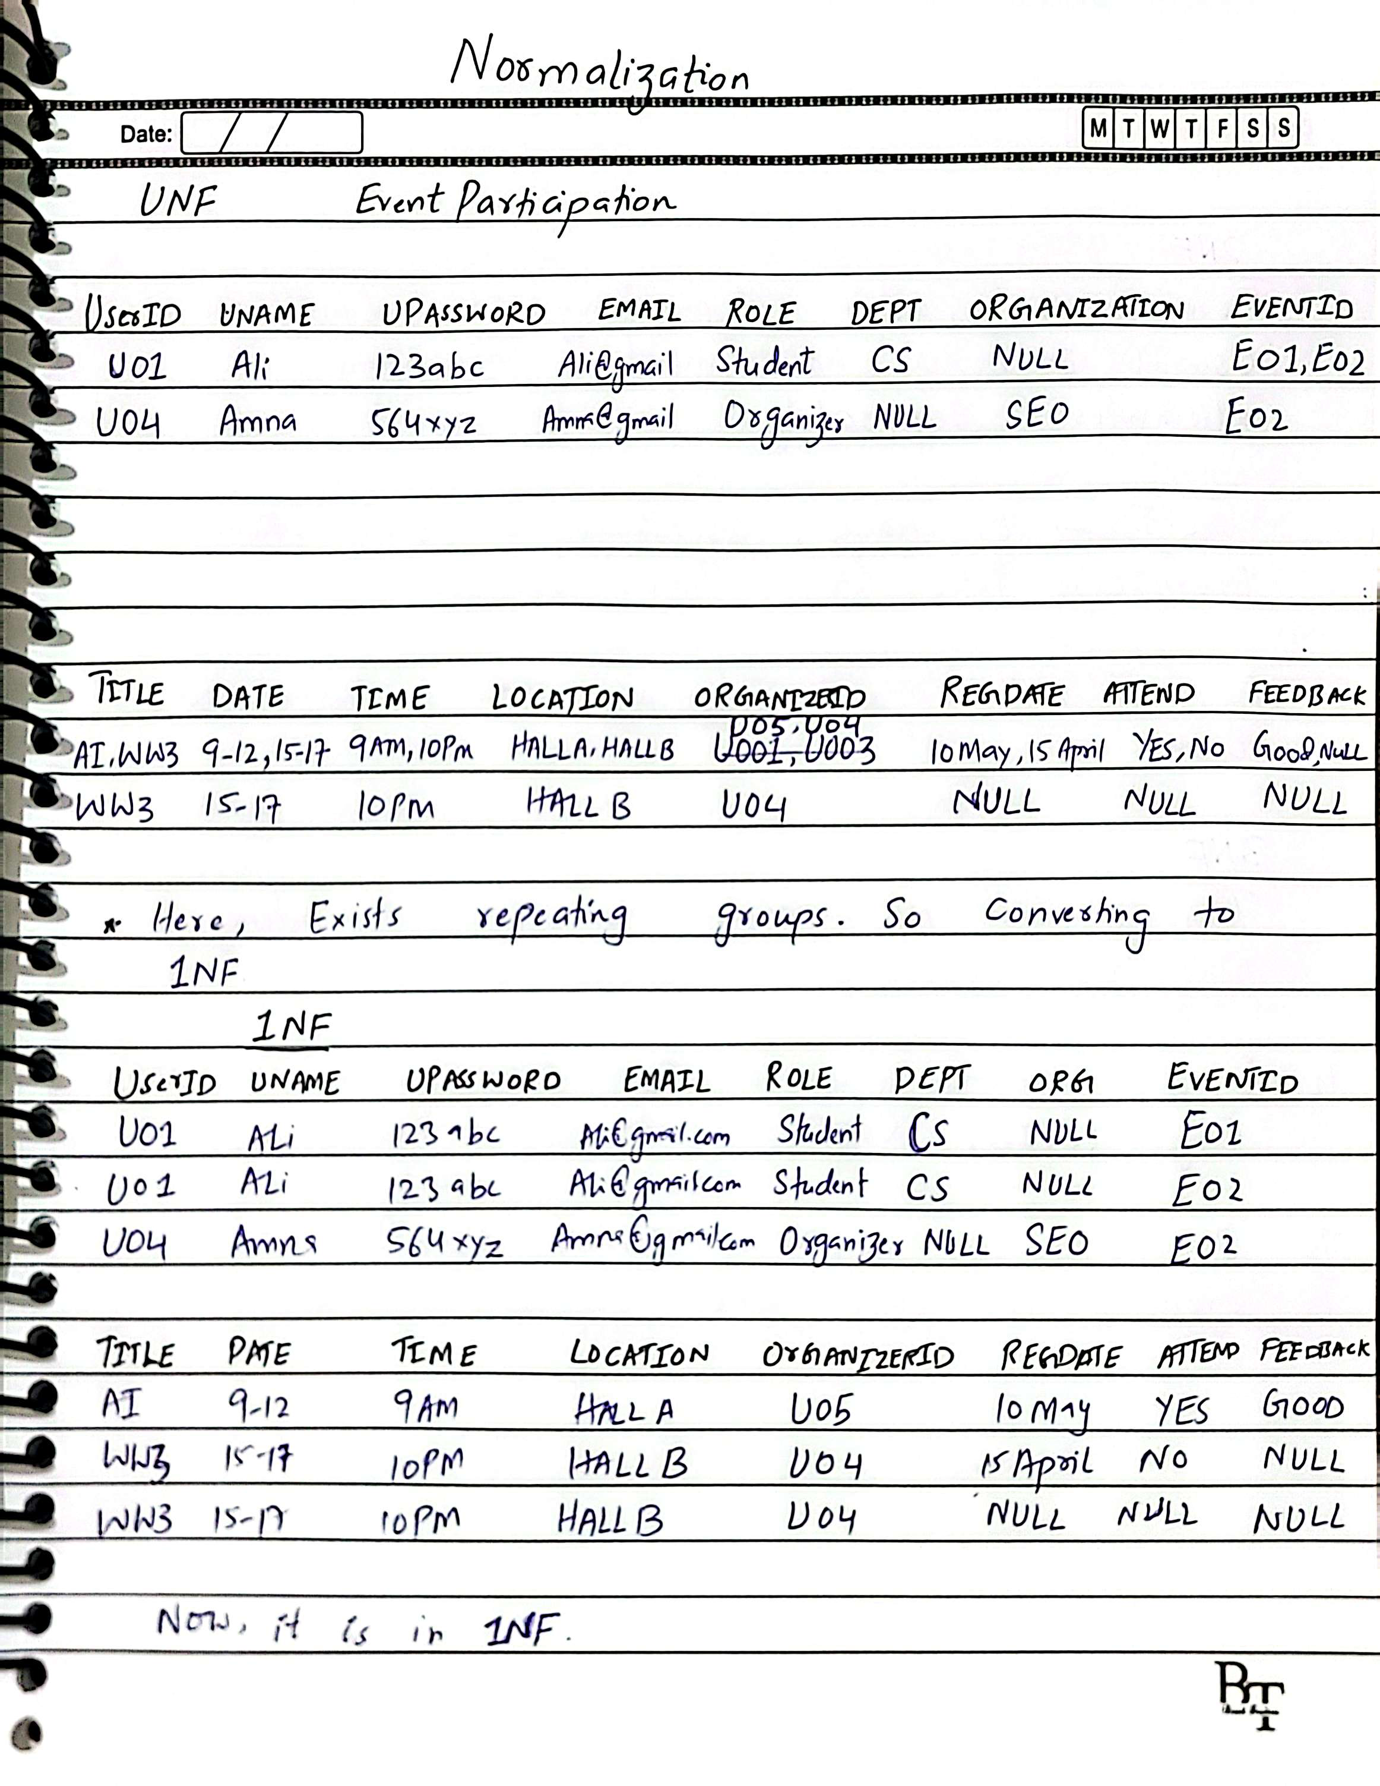

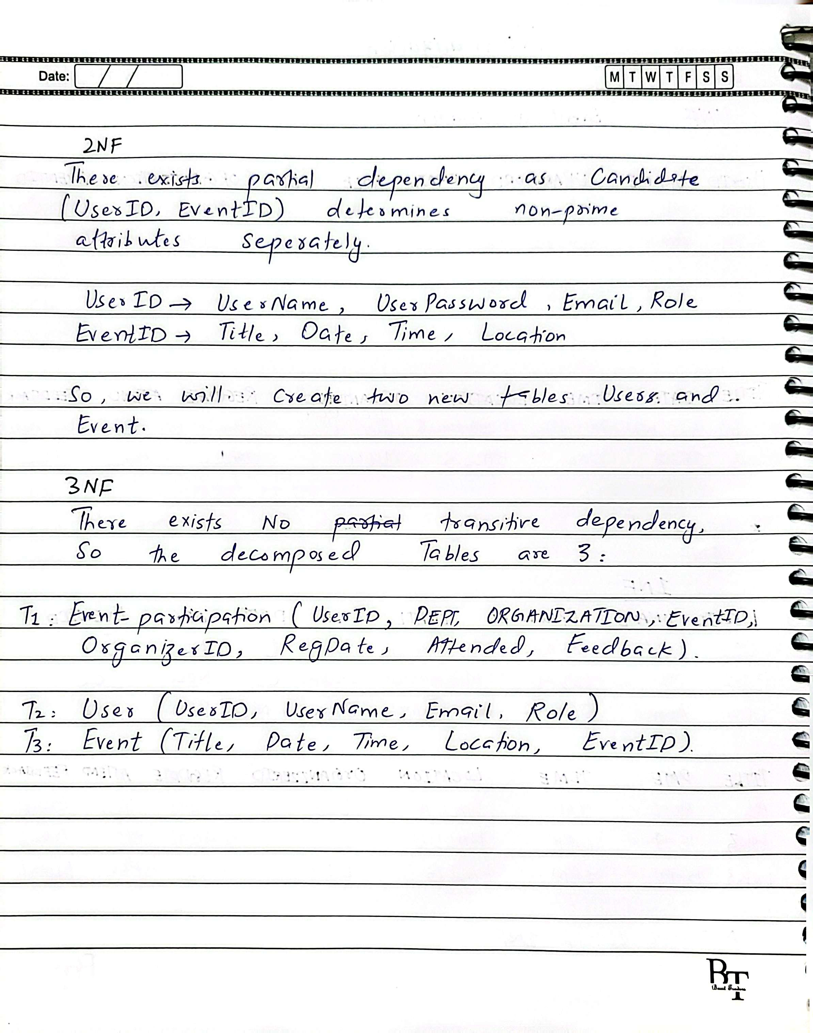

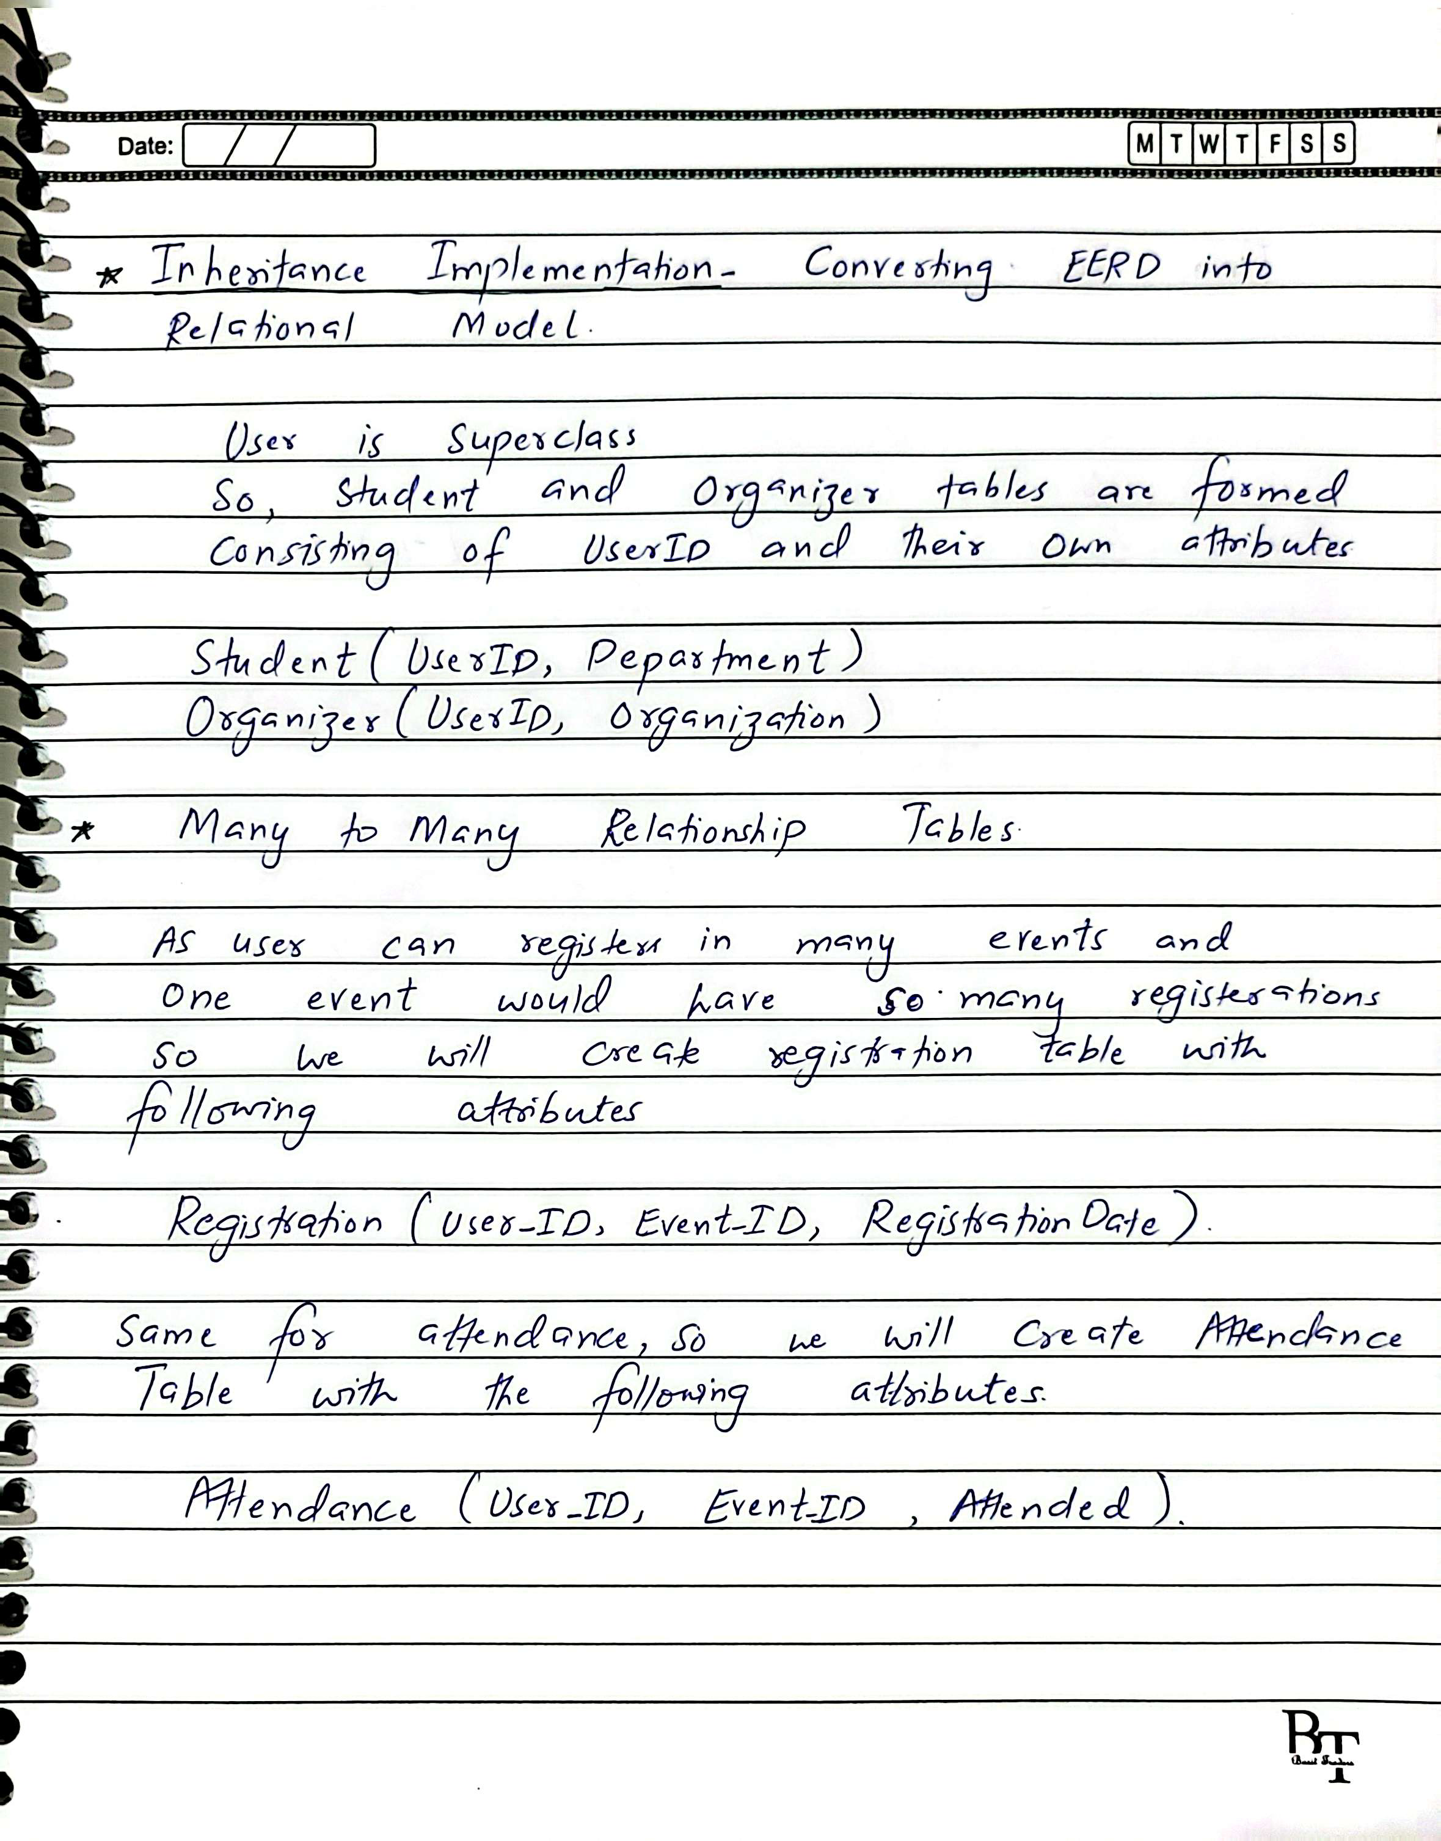

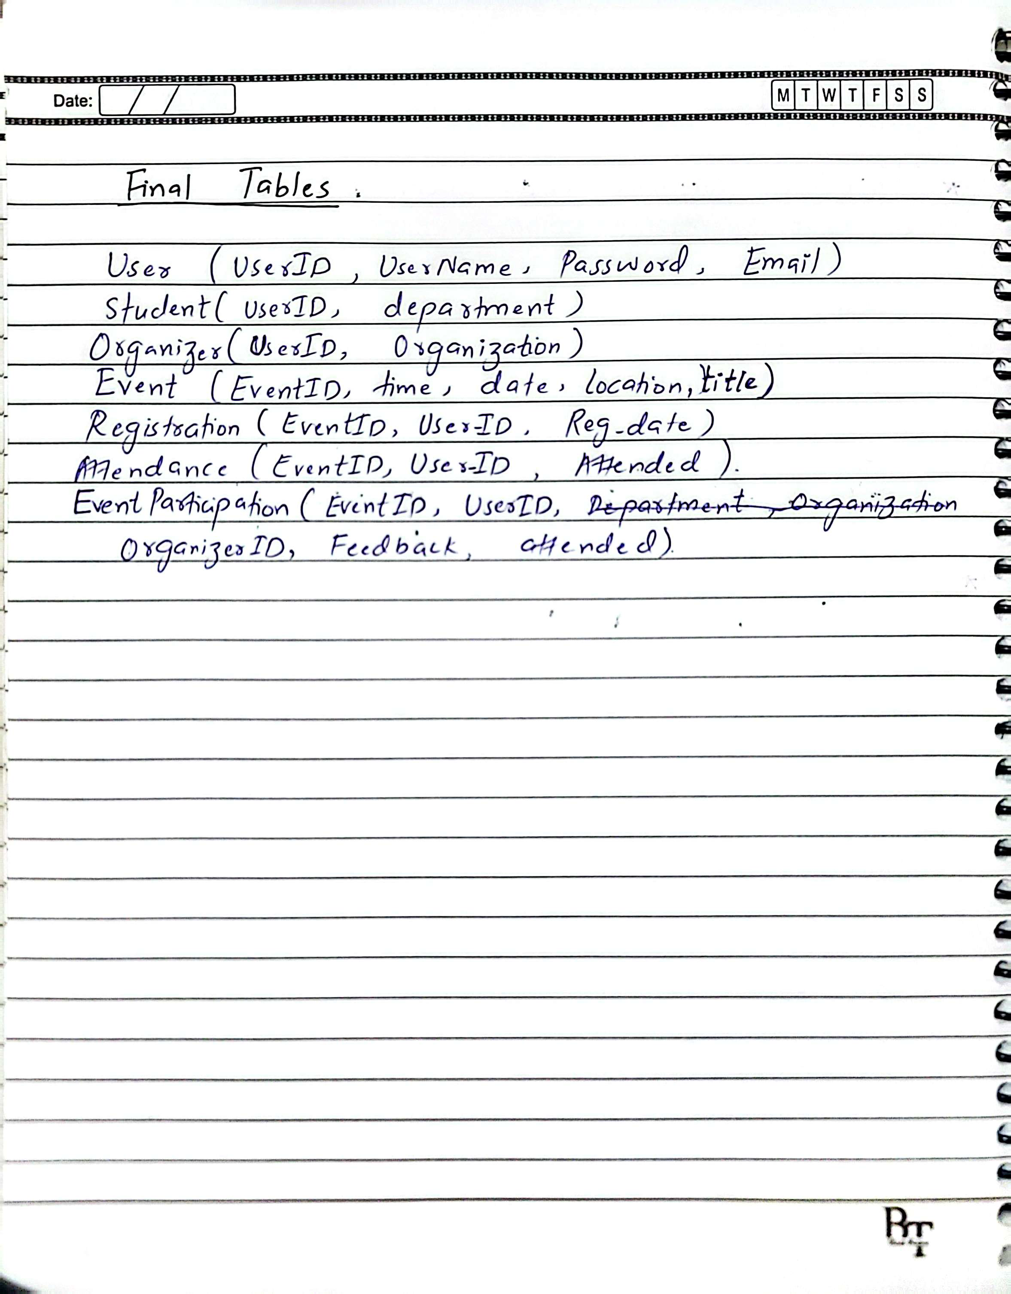

1. **DBMS and Programming Language Integration**

* I have used MySQL as a Database Management System.
* I have used java as programming language to develop CLI Based application to interact with database implemented.
* The integration was achieved using **JDBC** and the official **MySQL Connector/J** driver.

**Libraries and Packages**

* The application uses the java.sql package for:

Establishing DB connections

Executing SQL queries (CRUD)

**Features Implemented**

**CRUD Operations:**

* **Create:** Add new users, events, attendance, and registration.
* **Read:** View events, feedback, attendance, registration.
* **Update:** Modify event details or user profiles.
* **Delete:** Remove users or events

**Querying and Reporting:**

* View all events attended by a specific student.
* Identify students who have not attended any event.

**Validation and Error Handling:**

* Checks for duplicate UserID, EventID.
* Handles empty input and invalid choices gracefully.

1. **Final View of the Database**

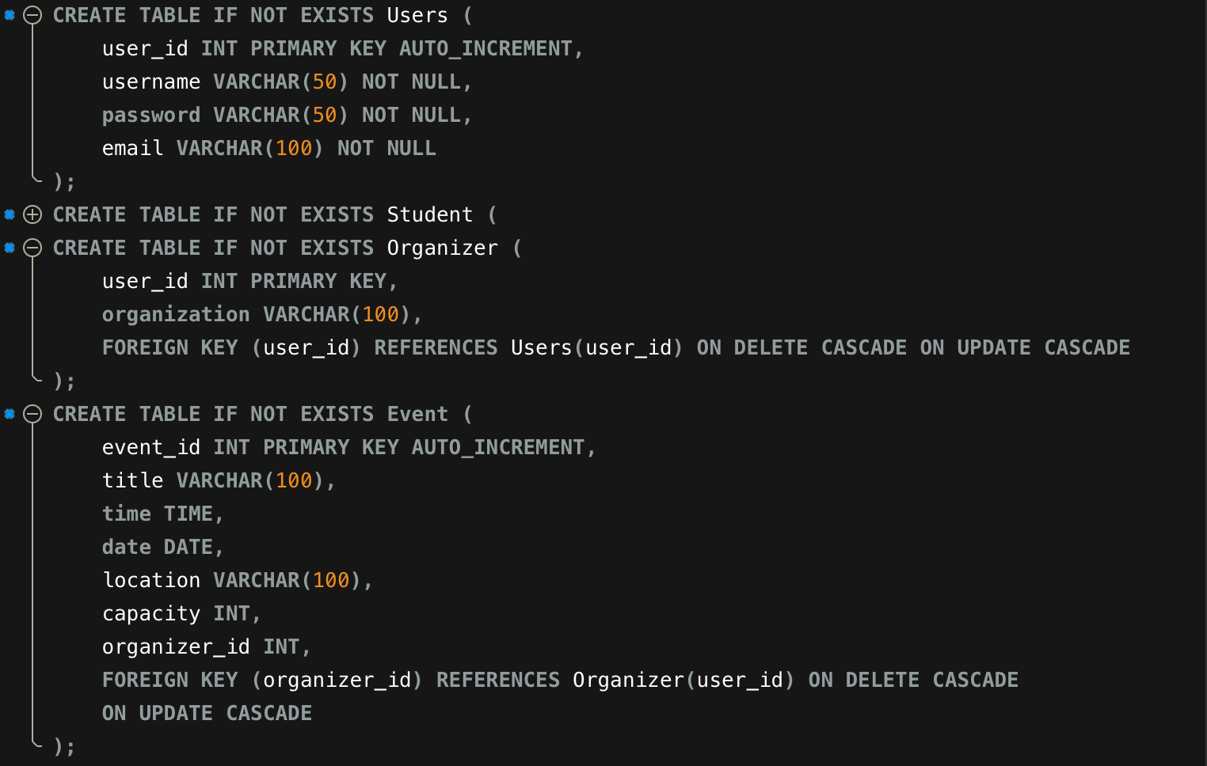

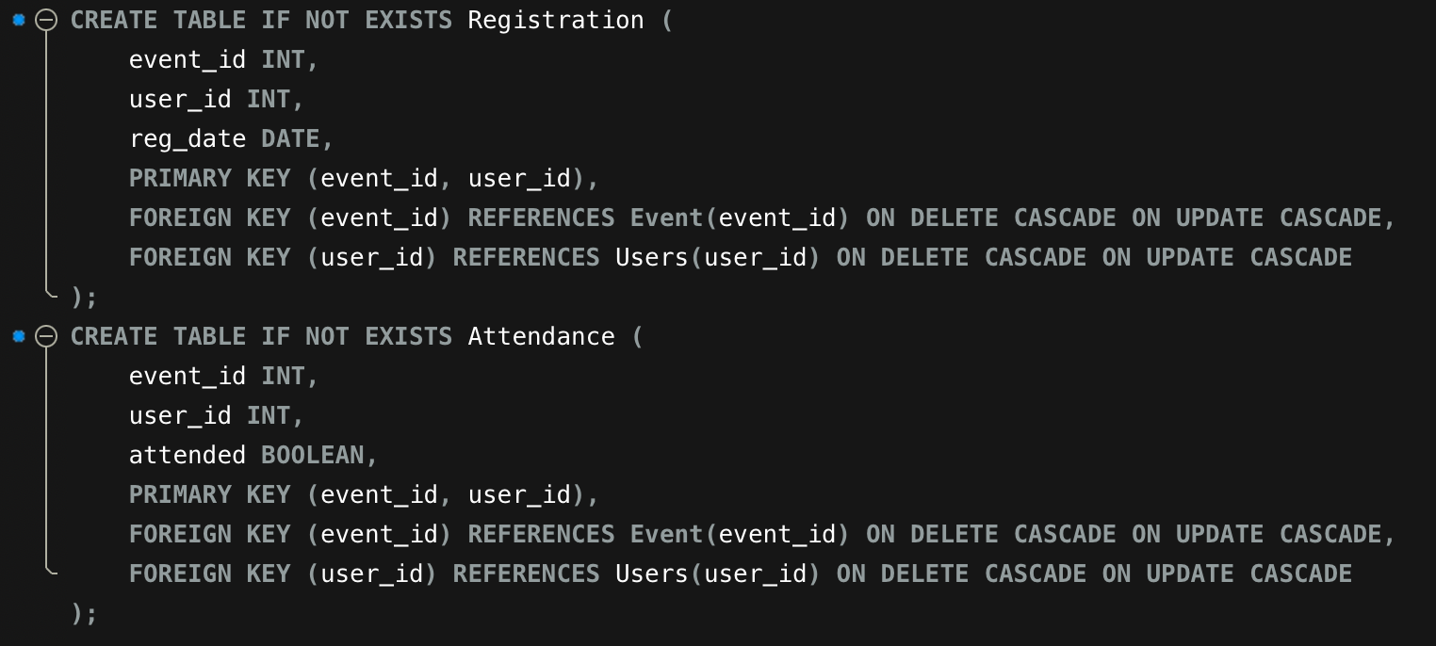

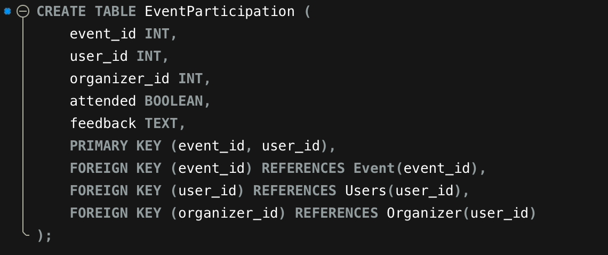

Sample records (at least 5 per table).

Users

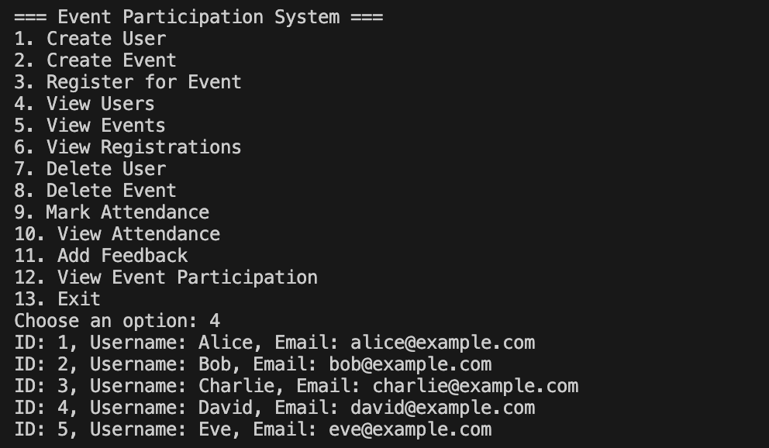

EVENTS

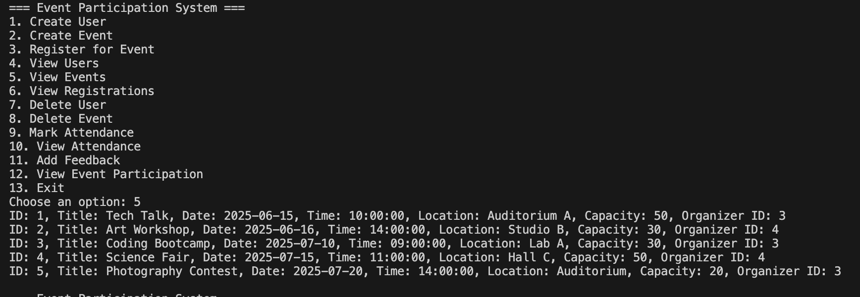

Registrations

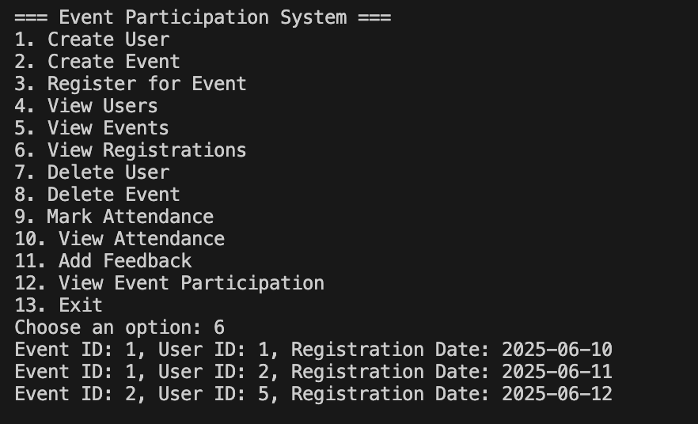

Attendees

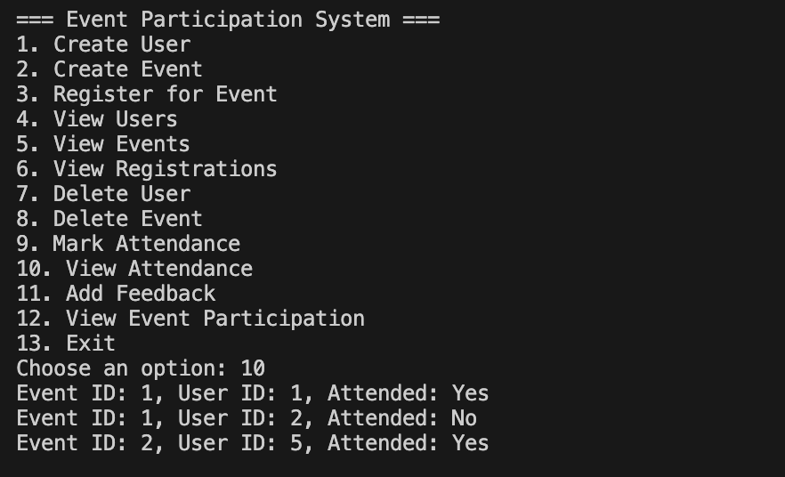

Event_Participation with Feedback

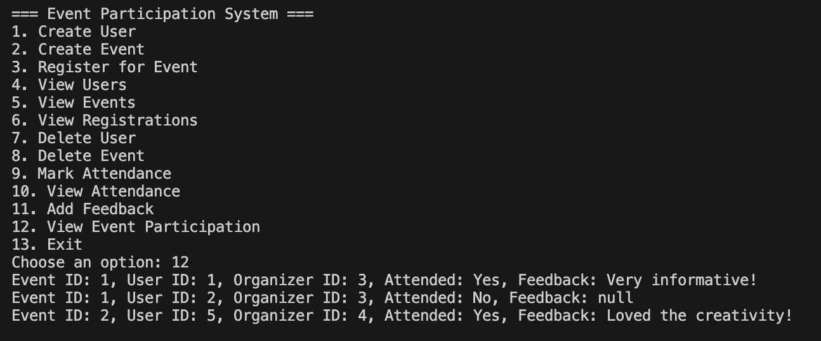

Documentation

**1. Primary and Foreign Key Constraints**

**Table: Users**

**Primary Key**: user_id

**Table: Student**

* **Primary Key: user_id**
* **Foreign Key: user_id → Users(user_id)**

**Table: Organizer**

* **Primary Key: user_id**
* **Foreign Key: user_id → Users(user_id)**

**Table: Event**

* **Primary Key: event_id**
* **Foreign Key: organizer_id → Organizer(user_id)**

**Table: Registration**

* **Primary Key: (event_id, user_id)**
* **Foreign Keys:**
  + **event_id → Event(event_id)**
  + **user_id → Users(user_id)**

**Table: Attendance**

* **Primary Key: (event_id, user_id)**
* **Foreign Keys:**
  + **event_id → Event(event_id)**
  + **user_id → Users(user_id)**

**Table: EventParticipation**

* **Composite Primary Key: (event_id, user_id)**
* **Foreign Keys:**
  + **event_id → Event(event_id)**
  + **user_id → Users(user_id)**
  + **organizer_id → Organizer(user_id)**

**2. Cascading Rules**

**The following cascading rules are applied to all foreign keys.**

**ON DELETE CASCADE**

**ON UPDATE CASCADE**

**3. Indexes**

**Indexes are implicitly created for:**

* **Every PRIMARY KEY field.**
* **Every FOREIGN KEY field.**

**So the following fields are indexed:**

* **Users(user_id)**
* **Student(user_id)**
* **Organizer(user_id)**
* **Event(event_id), Event(organizer_id)**
* **Registration(event_id), Registration(user_id)**
* **Attendance(event_id), Attendance(user_id)**
* **EventParticipation(event_id), EventParticipation(user_id), EventParticipation(organizer_id)**

**But No Implicit indexes are created.**

**4. Sample Queries Used in Application**

**Create User**

**INSERT INTO Users (username, password, email) VALUES ('john', 'pass123', 'john@example.com');**

**Create Event**

**INSERT INTO Event (title, time, date, location, capacity, organizer_id)**

**VALUES ('Tech Talk', '10:00:00', '2025-06-20', 'Auditorium', 50, 3);**

**Register for Event**

**INSERT INTO Registration (event_id, user_id, reg_date)**

**VALUES (1, 2, CURDATE());**

**Mark Attendance**

**INSERT INTO Attendance (event_id, user_id, attended)**

**VALUES (1, 2, TRUE);**

**Insert into EventParticipation**

**INSERT INTO EventParticipation (event_id, user_id, organizer_id, attended, feedback)**

**VALUES (1, 2, 3, TRUE, 'Very informative');**

**View All Events**

**SELECT * FROM Event;**

Code documentation:

**Core Classes & Methods**

* **Main Class**
  + Contains the menu loop and all user interaction logic.
  + Establishes database connection using JDBC.
* **Important Methods**
  + createUser(): Adds a new user to the system.
  + createEvent(): Inserts a new event.
  + registerForEvent(): Adds a user registration.
  + markAttendance(): Marks user attendance and stores it in EventParticipation.
  + addFeedback(): Updates feedback for attended events.
  + view*(): Multiple methods to view users, events, registrations, and participation.
* **DataBase Class**
  + Provides createTables() method to initialize all required tables if they don’t already exist.